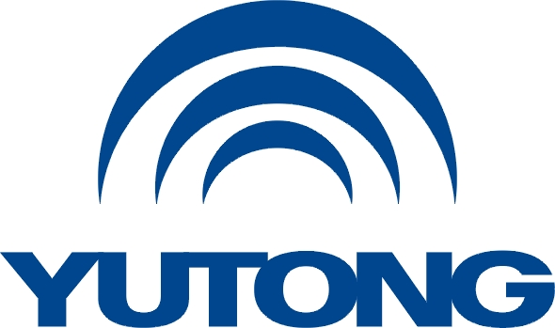

**Media Kit**

**For the Busworld Europe 2025**

**Yutong Overview**

Yutong Bus Co., Ltd.

October, 2025

**Yutong Overview**

**Company overview**

Yutong is a large commercial vehicle group mainly engaged in bus and truck production, with its product lineup covering buses, trucks, construction machinery, special vehicles and sanitation equipment. It boasts one engineering technology research center, two listed companies (Yutong Bus, SH.600066; Yutong Heavy Industries, SH.600817), four complete vehicle plants and five parts bases. In 2024, it sold 65,236 units of commercial vehicles, generating an operating revenue of 443 billion RMB, sustaining its leadership in the NEV sector. After 30 years of development, more than 220,000 new energy commercial vehicles have been sold, making Yutong the world’s largest bus enterprise and new energy commercial vehicle group.

Yutong Bus, as the flagship division of Yutong Group, is a globally renowned leader in the bus industry. Its product range caters to diverse market segments, including long distance coaches, tourist coaches, city buses, commuters, school buses, sightseeing vehicles, apron buses, autonomous driving micro-circulation buses and special vehicles. In 2024, Yutong Bus sold 46,918 units, maintaining over 30% market share in the 6m+ vehicle segment, leading the industry for 23 consecutive years. With nearly 110,000 vehicles exported to over 60 countries across the Americas, Europe, Asia, and Africa, it holds nearly 10% global market share. As a leading international bus manufacturer, Yutong continues its steady, high-quality growth worldwide.

**Global Presence**

As a leading global bus manufacturer, Yutong Bus serves over 100 countries and regions, including Europe, the Americas, Africa, Asia-Pacific, and the Middle East. Its product portfolio spans multiple segments: coach, city bus, commuter, school bus, sightseeing vehicle, airport bus, micro-circulation bus and special vehicle.

To date, Yutong has sold over 200,000 new energy buses worldwide, capturing nearly 10% of the global market share. These vehicles have reduced carbon emissions by 28.7 million tons, equivalent to planting 140,000 hectares of forest.

Yutong has established a global presence across target markets, operating through over 70 subsidiaries, offices, dealers, and direct sales teams covering six major regions: Europe, the Americas, Asia-Pacific, CIS, the Middle East, and Africa. Yutong has more than 400 authorized service outlets worldwide with an average service radius of 150 km. With over 40 parts warehouses in countries including Colombia, Chile, Mexico, Kazakhstan, Tanzania, and Uzbekistan, plus a network of 80 authorized parts dealers, Yutong ensures fast and efficient parts supply for end users. A service team of 800+ customer service managers operates globally, handling customer needs identification, technical training, and vehicle troubleshooting. Yutong provides 24/7 online support with 10-minute response times, year-round direct service, and immediate vehicle maintenance assistance.

Yutong has established localized partnerships through KD assembly in over ten countries including Kazakhstan, Pakistan, Egypt, and Malaysia. This marks a transition from product export to technology and solution export, enabling these countries to develop local bus manufacturing capabilities.